Branding Font

FONT INFORMATION
- Font: Blackout Midnight
- Weight: Midnight
- Version: Version Version 2.001
- No. of Characters: 102
- Encoding Scheme:
- Is Fixed Pitch: No

CHARACTERS
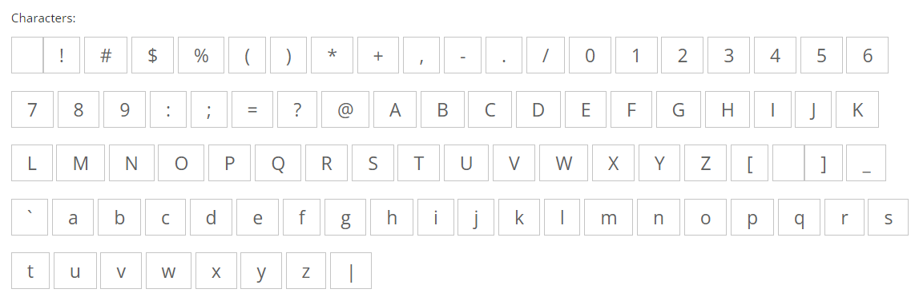

UPPERCASE
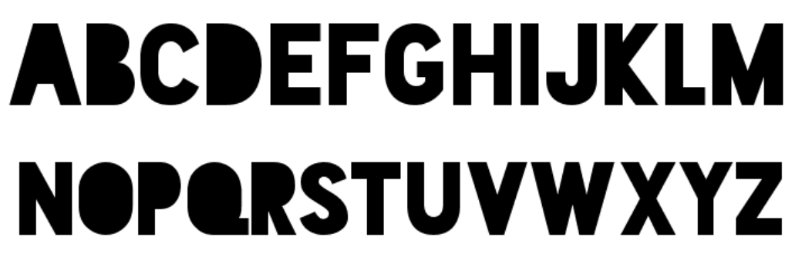

LOWERCASE


